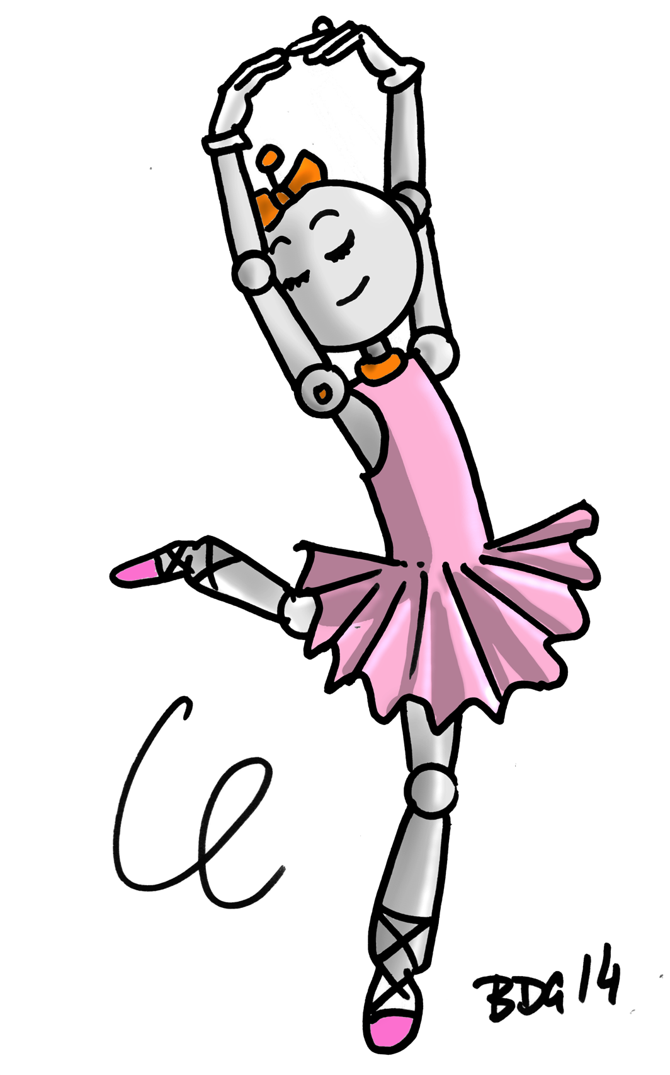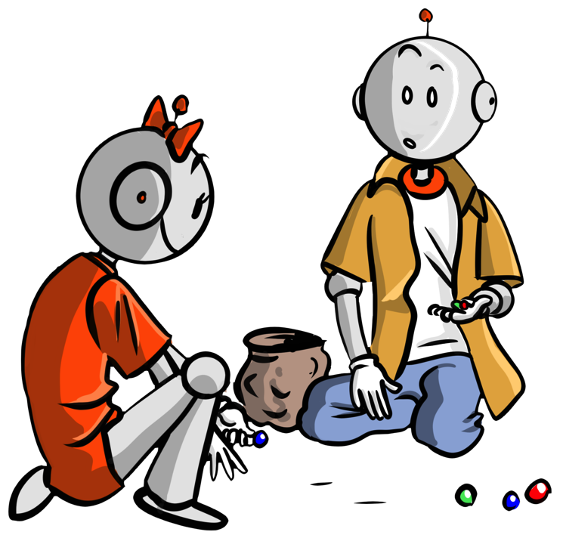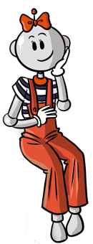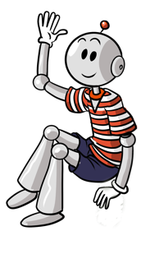

|  |  |  |  |  |  |  |  |  |  |  |
| --- | --- | --- | --- | --- | --- | --- | --- | --- | --- | --- |
| A | P | A | a | A | e | U | u | V | N | M |
| A | A | A | U | A | y | y | Y | A | y | Y |
| Y | y | Y | d | a | y | V | y | V | Y | T |
| P | V | Y | I | V | Y | O | y | Y | y | V |
| R | u | y | y | y | Y | V | A | E | N | d |

Colorie la lettre Y, y , **Y** ,y

3

**La lettre Y , y ,Y , y**

|  |  |  |  |  |  |  |  |  |  |  |
| --- | --- | --- | --- | --- | --- | --- | --- | --- | --- | --- |
| T | I | i | I | L | E | U | t | z | t | L |
| L | i | o | i | o | T | i | i | i | L | O |
| i | i | v | I | i | C | I | t | I | t | I |
| I | t | U | L | i | t | i | L | i | i | i |
| i | L | M | P | i | i | i | T | E | S | d |

Colorie la lettre A, a ,**A,** A , a

1

|  |  |  |  |  |  |  |  |  |  |  |
| --- | --- | --- | --- | --- | --- | --- | --- | --- | --- | --- |
| A | P | **A** | a | **a** | e | **U** | d | B | N | M |
| a | A | a | U | **A** | T | d | **a** | A | **A** | q |
| N | V | e | d | a | p | o | a | K | a | Q |
| P | E | O | e | A | **a** | O | **A** | O | a | a |
| Z | u | P | T | V | A | a | A | E | S | d |

Colorie la lettre **R , r ,R , r**

|  |  |  |  |  |  |  |  |  |  |  |
| --- | --- | --- | --- | --- | --- | --- | --- | --- | --- | --- |
| A | r | r | R | R | e | R | R | r | N | M |
| A | r | A | U | **r** | R | r | a | **r** | A | q |
| N | R | e | d | a | p | B | R | R | a | Q |
| R | r | s | I | A | a | O | r | O | R | r |
| Q | u | P | A | V | A | a | r | R | r | d |

**La lettre R , r ,R , r**

Colorie la lettre i ,**I,** **I** , i

**La lettre i , i ,I, I , i**

**La lettre A ,** **A, a ,A, A , a**

2

4