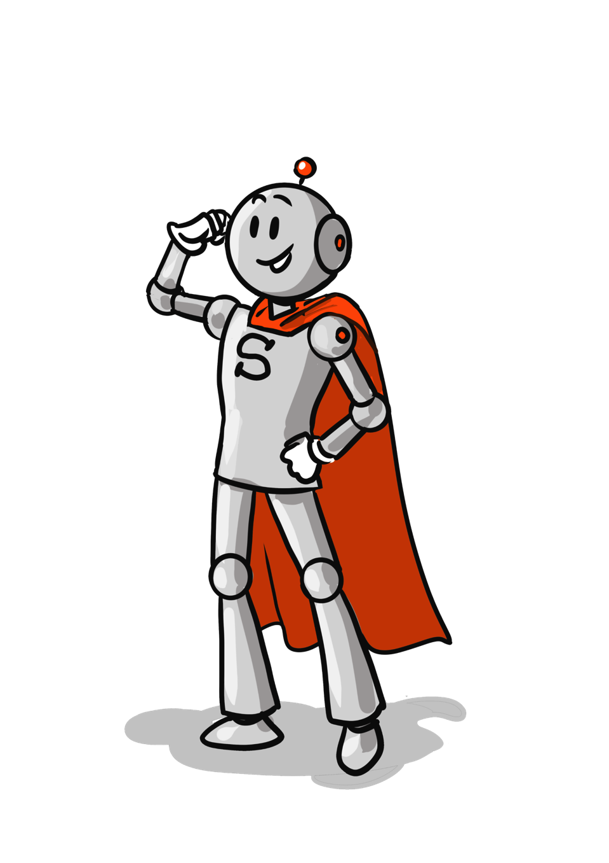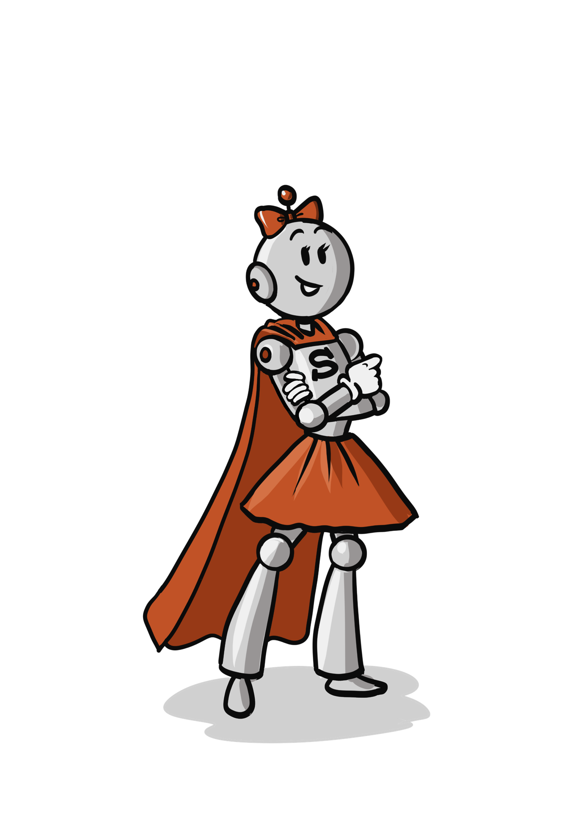

Super Robotine

Super Tirobot

Super Tirobot

Super Robotine

Super Tirobot

Super Robotine

Super Tirobot

Super Robotine

Super Tirobot

Super Robotine