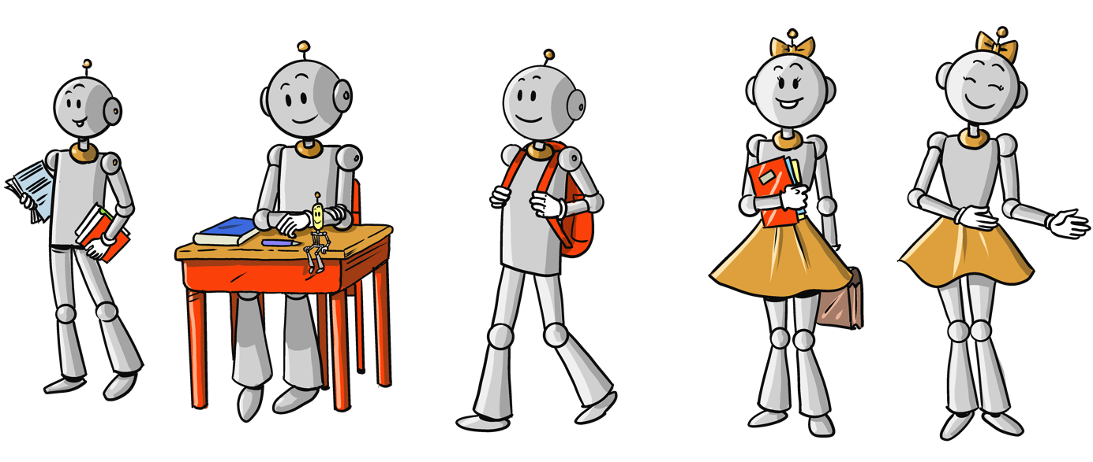

(EmplOi Du Temps CP CE1)

_ _ _ _ _ _ _ _ _ _ _ _ _ _ _ _ _ _ _ _ _ _ _ _ _ _ _ __ _ _ _ _ _ __ _ _ _ _ _ __ _ _ _ _ _ __ _ _ _ _ __ _ _ _ _ _ _ _ _ _ _ _ _ _ _ _ _ _ _ _ _ _ _

_ _ _ _ _ _ _

_ _ _ _ _ _ _

_ _ _ _ _ _ _

_

_ _ _ _ _ _ _

_ _ _ _ _ _ _

|  |  |  |  |  |  |  |  |  |  |  |  |  |  |  |  |  |  |  |
| --- | --- | --- | --- | --- | --- | --- | --- | --- | --- | --- | --- | --- | --- | --- | --- | --- | --- | --- |
|  | **LUNDI** | | | | | | **MARDI** | | |  | **JEUDI** | | | **VENDREDI** | | | | |
| CP | | CE1 | | | | CP | | CE1 | CP | CE1 | | CP | | | CE1 | |
| 8H30-8H45 | Rituels, Appel, cantine, date, météo, | | | | | | | | |  | Rituels, Appel, cantine, date, météo, | | | | | | | |
| 8H45-9H00 | Rituels lecture ou maths | | | | | | | | | Rituels lecture ou maths | | | | | | | |
| 9H00-  10H15 | Ecriture/  graphisme | | | Lecture | Lecture | | | Rallye lecture | | Phonologie | Grammaire Ex | | Langage | | Rallye lecture | | |
| Ecriture | | Copie dictée préparée | | Lecture | | dictée | | |
| Lecture | | | Grammaire | | Lecture | Lecture | | dictée | | Lecture | | |
| Phonologie | Ecriture | | | Production d’écrits | Production d’écrits | | Lecture plaisir et langage | | | | |
| 10H15-10H35 | RECREATION | | | | | | | | |  | | | | | | | |
| 10H35-  11H30 | Calcul mental | | | | | Calcul mental | | | | Calcul mental | | Calcul mental | | | | | |
| Numération | | | | | Numération | | | | Numération | | Numération | | | | | |
| Calcul | | | Problèmes | | | Calcul | Problèmes | | Géométrie | Problèmes | | Calcul | | | | Problèmes |
| Calcul | | | Calcul | | Calcul | Géométrie | | Géométrie | | | | Géométrie |
| 11H30-11H45 | Anglais | | | | | | | | | Anglais | | | | | | | |
|  | REPAS | | | | | | | | | REPAS | | | | | | | |
| 13H45-14H15 | Rituels Arts /poésie | | | | | | | | | Rituels Arts/poésie | | | | | | | |
| 14H15-14H45 | Phonologie : chant | Phonologie : Exercice | | | Phonologie lecture | | | Rallye copie | | Ateliers Maths/français | | | | Questionner le monde | | | |
| 14H45-15H15 | Questionner le monde | | | | Questionner le monde | | | | |
|  | Lecture plaisir | | | | Poésie | | | |
| 15H15-15H35 | RECREATION | | | | | | | | | RECREATION | | | | | | | |
| 15H35-16H30 | EPS | | | | Lecture /Musique / Ecriture | | | | | EPS | | | | EMC / Bilan de la semaine | | | |